* Start the project with the ModernHouseStart.max and Textures_ModernHouse.zip. Make sure you have the resolution of textures (Viewport Configuration settings) to 4096 and the Units setup to metric system:

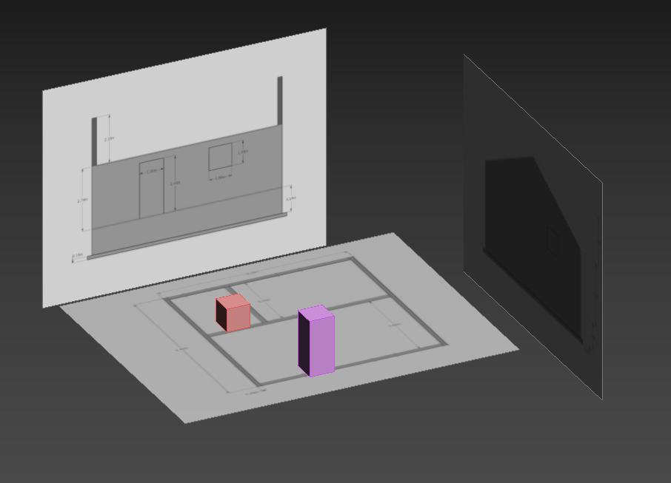

* To start with the creation of walls, create a cube with 0.2m width and 3.33m Length, 2.74m of height. Don’t forget to change the Z to 0.15m up the scene to match the reference images:

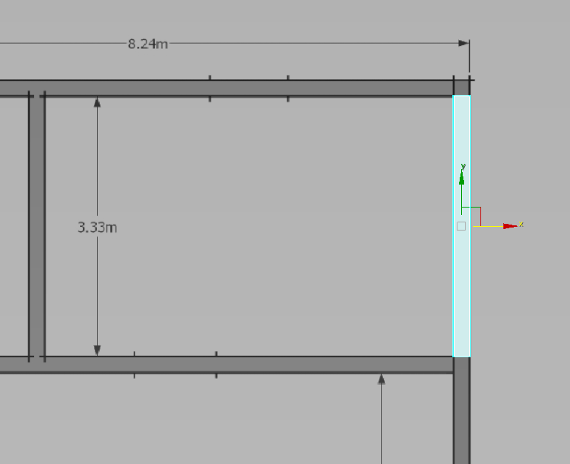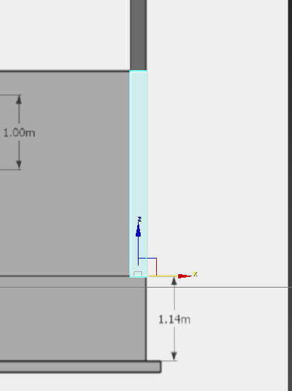

* Add Edit Poly and start extruding 0.2m (thickness of the wall) extrude to each direction (I changed the color of the wall to see edges easier):

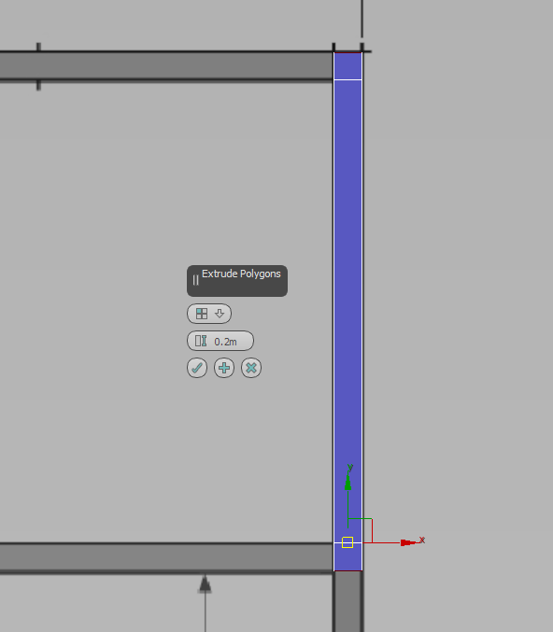

* Continuing extruding to match the reference images:

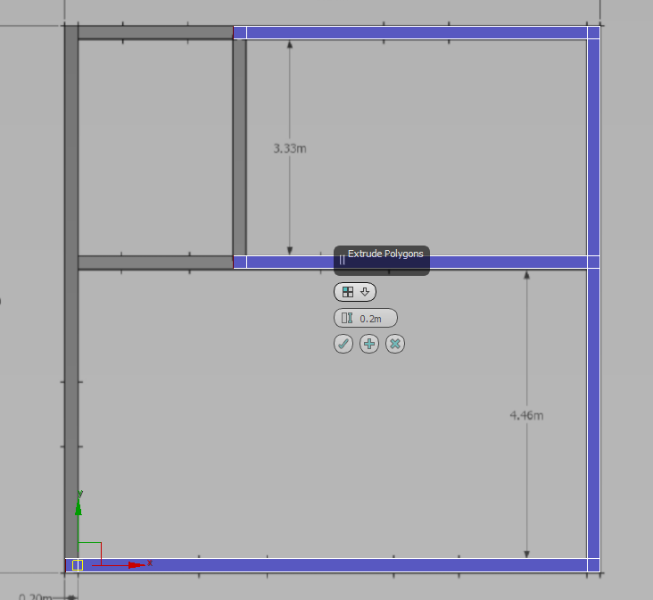

* Use Bridge tool to connect two walls together. Don’t forget to make sure all walls are aligned with Snap Toggle:

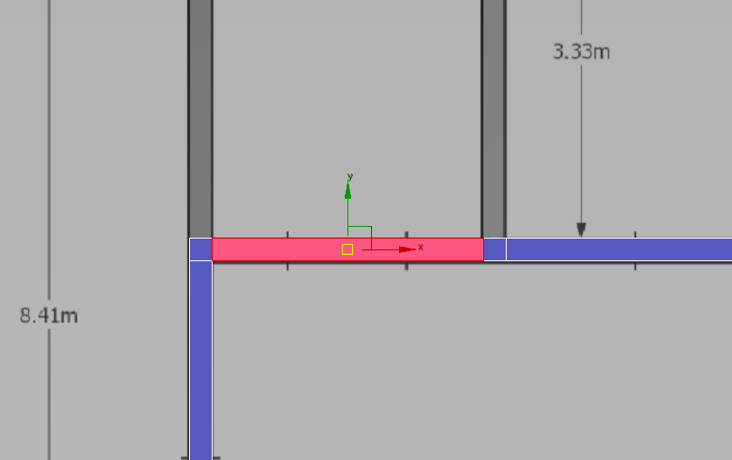

* Final result of the walls:

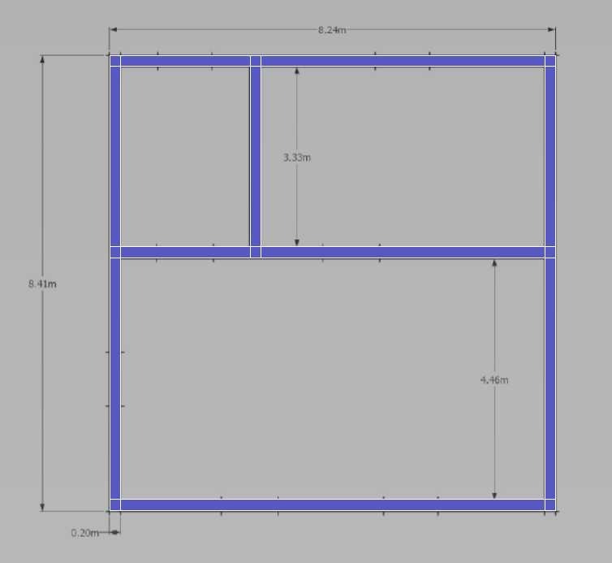

* Use the door and window boxes to position in the correct place:

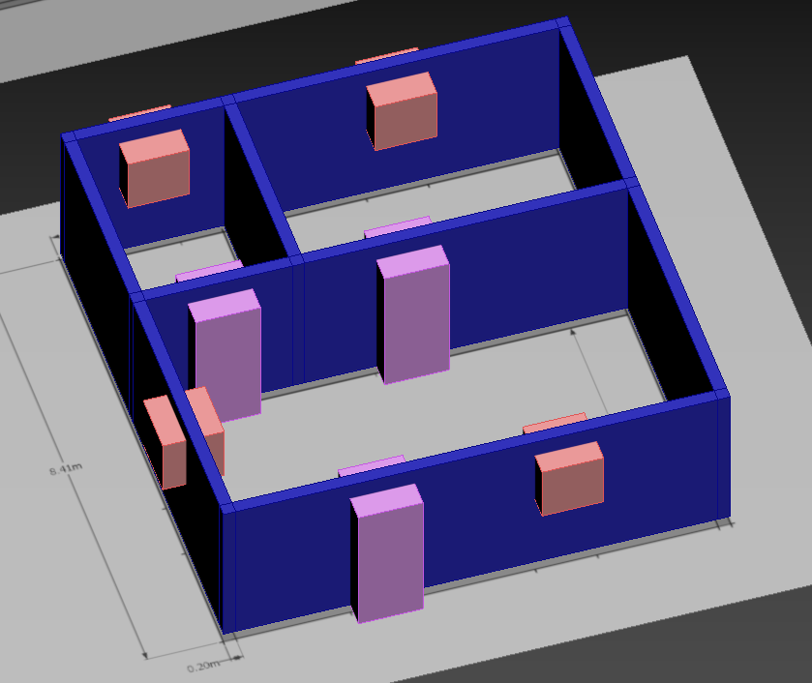

* With the references boxes positioned, we can go back to the wall mesh and set some of the connect tool to make the space for the windows and doors. Use the Snap Toggle to help position the new edges:

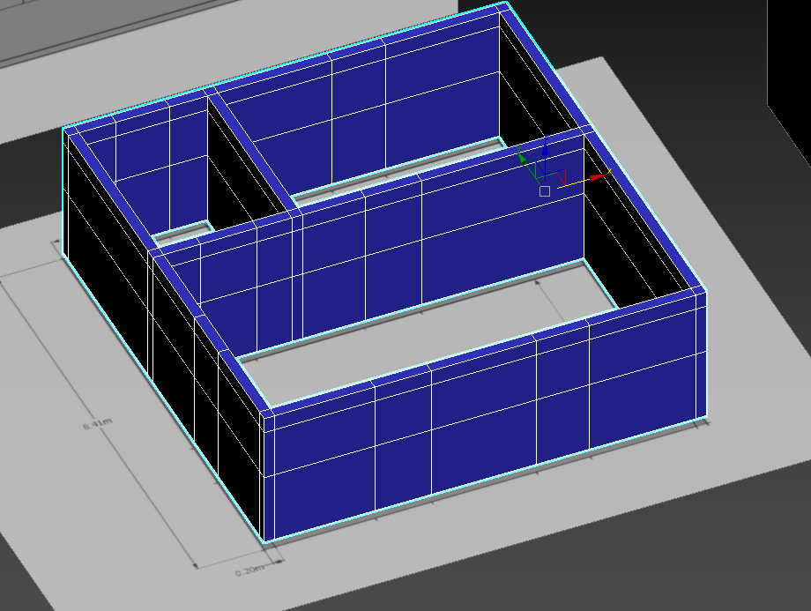

* Use Bridge tool to create the space for window and door spaces:

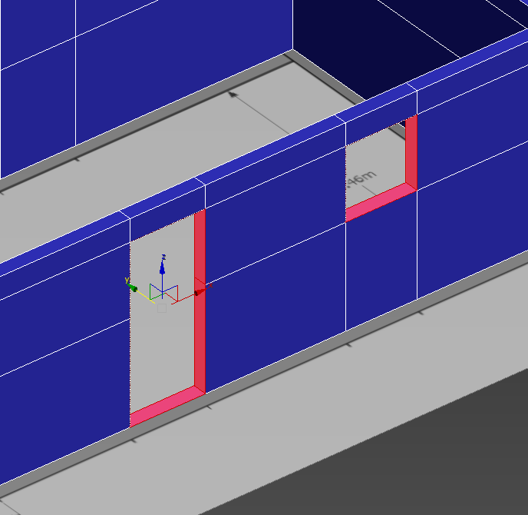

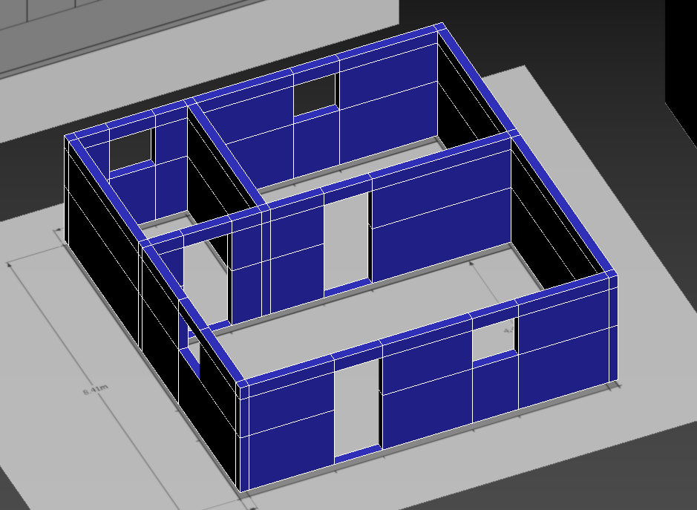

* Select the bottom polygons and delete them. Go to border mode and cap the pieces from the door piece:

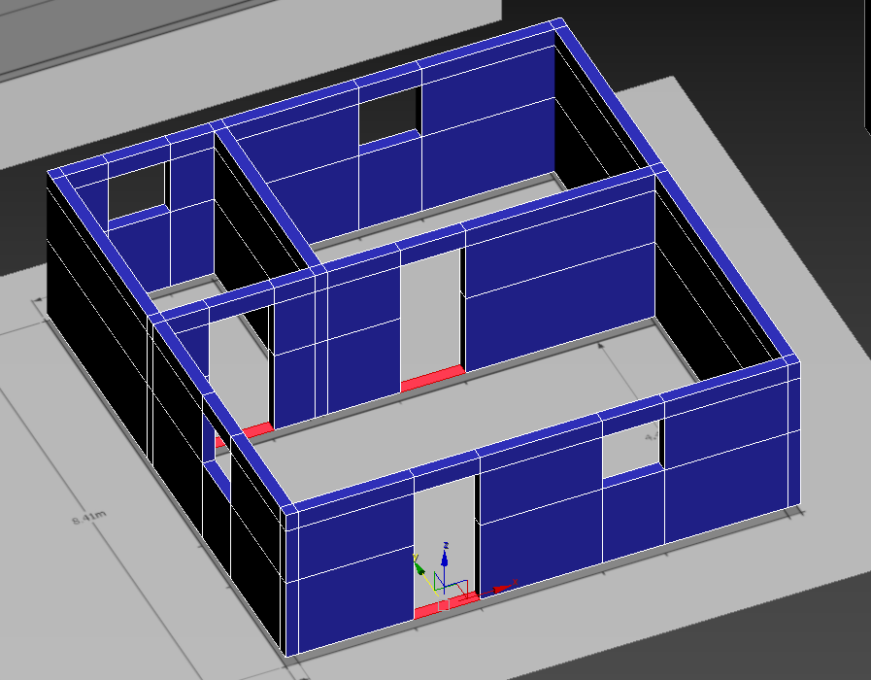

* Now we can add the Doors and Windows assets. Use the Snap Toggle to create each piece. The assets in this example are Pivot Doors and Fixed Windows:

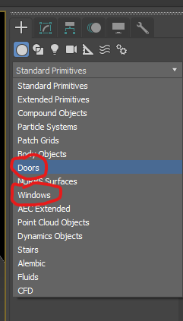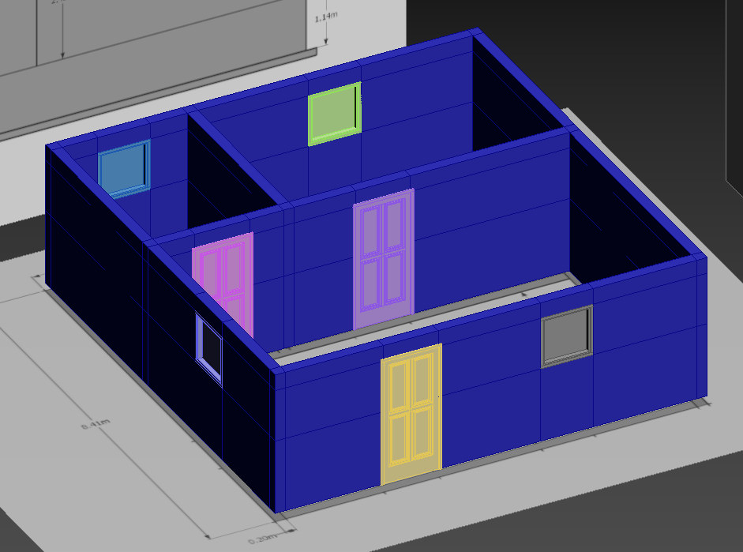

* Create the floor using a box, using Snap Toggle, and apply within the walls. The height is 0.15m:

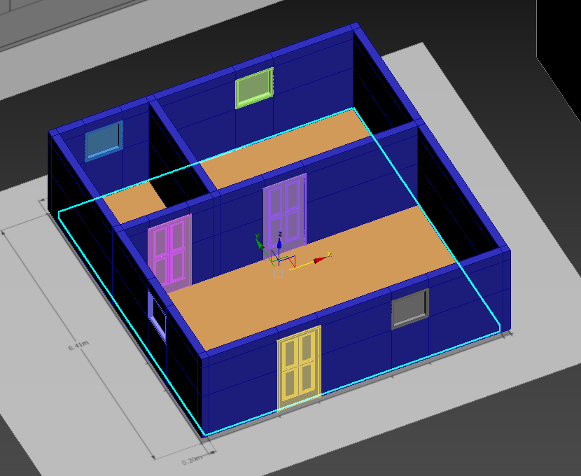

* Clone the floor to create the wall foundation. Move it down to -0.99m. Add Edit Poly modifiers, extrude the sides of the box by 0.2m. Select the top and bottom pieces and bridge to create the whole and leave only the walls:

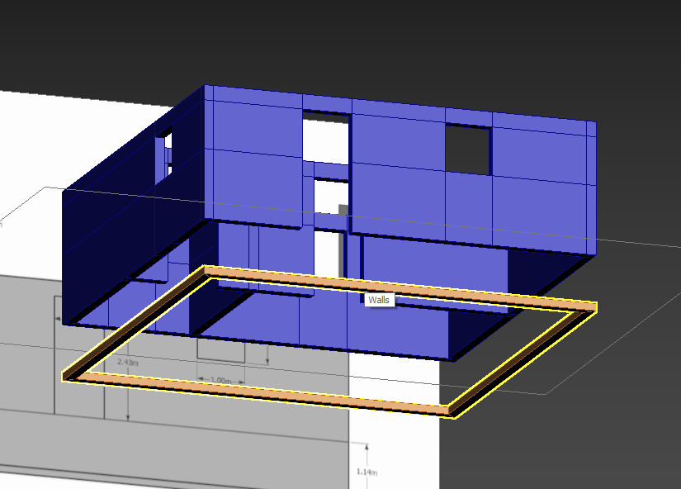

* Select the top of the mesh and move on Z to 0.15m:

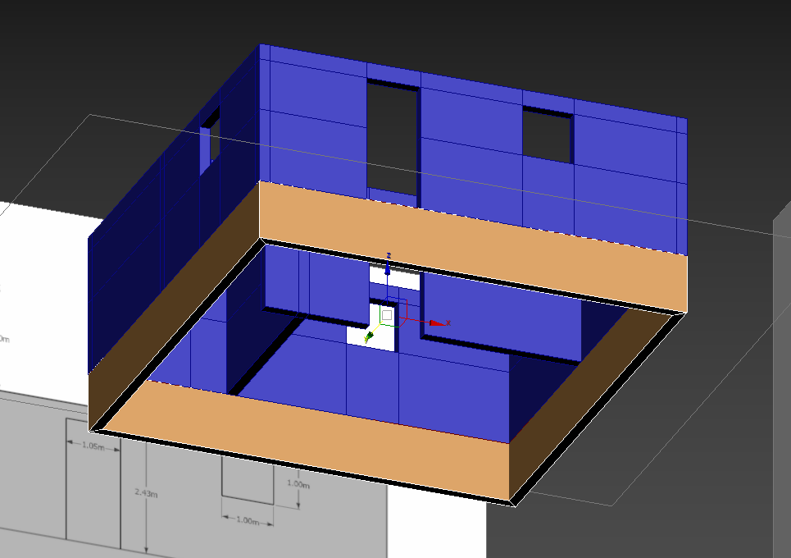

* Select the bottom of the mesh extrude them 0.15m. Select the detail around and extrude outwards and inwards by 0.2m:

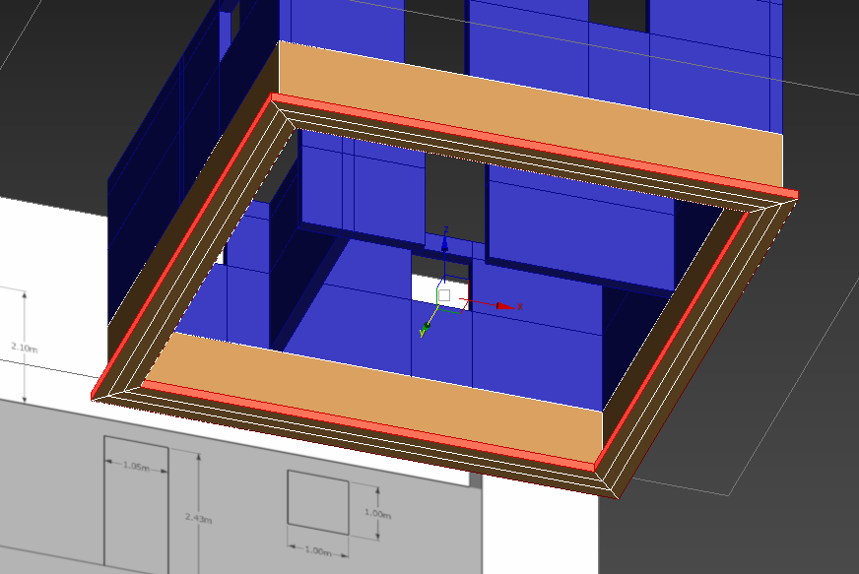

* Clone the floor once again and move it down to -0.99m to create the floor of the foundation:

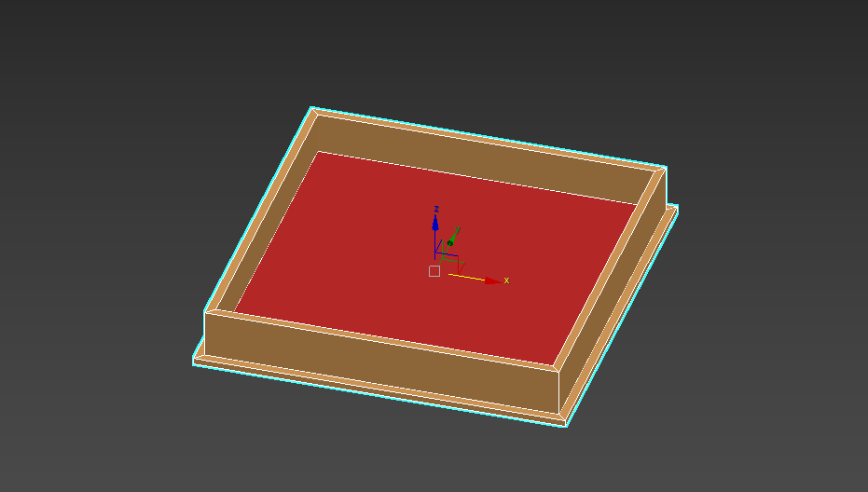

* Select the foundation floor, still as a box and add 4 segments for length and width to assist with the positioning of the structures that will hold the foundation. Once that’s done remove the segments:

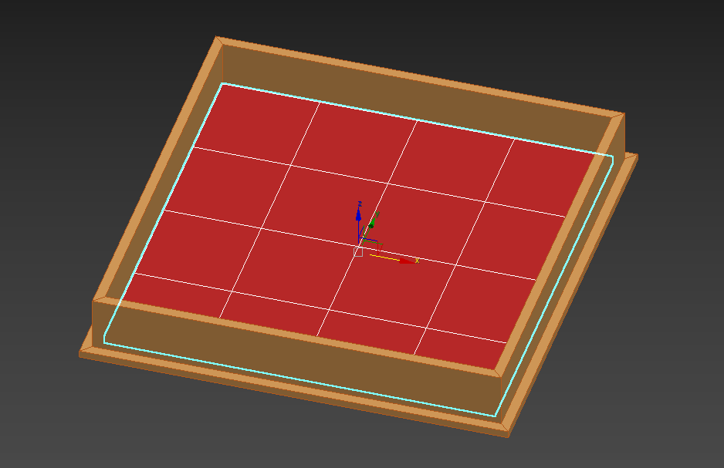

* Create a box, 0.3m x 0.3m x 0.9m. Snap to each intersection to create the supports:

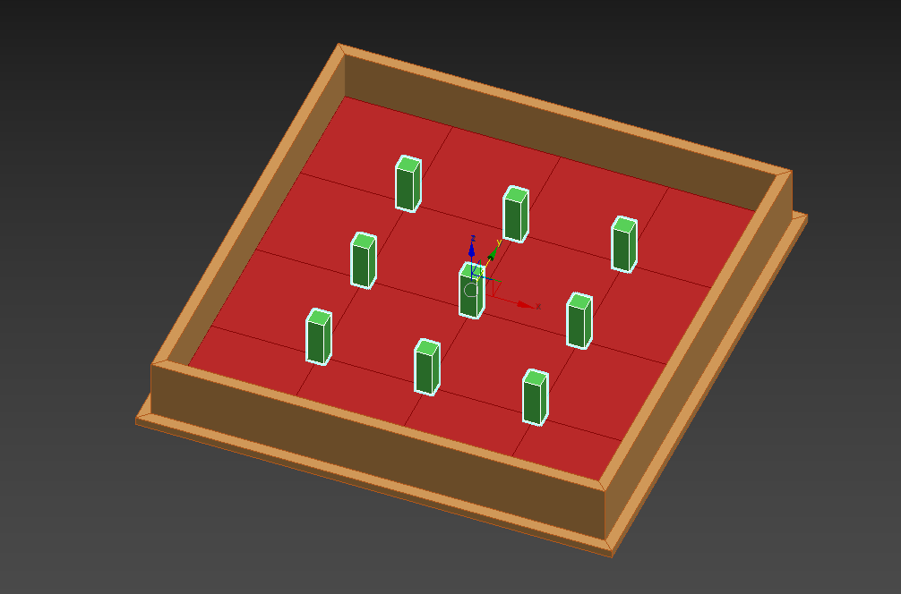

* Completed the first part of the house:

